Set 5: Elective 2: Australia’s engagement with Asia
Source 1
(A Liberal Party poster, 1966 federal election campaign.)
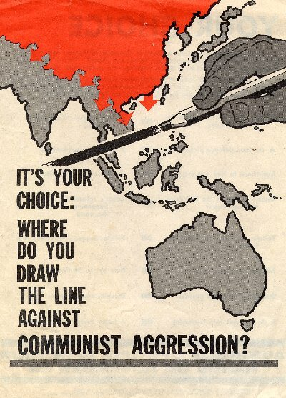

Source 2
(Extract from a speech by Opposition leader Arthur Calwell in the House of Representatives, May 1965, in response to the Coalition Government’s decision to send an infantry battalion to Vietnam.)

We do not think it is a wise decision. We do not think it is a timely decision. We do not think it is a right decision. We do not think it will help the fight against Communism … The Government takes the grotesquely over-simplified position that this is a straightforward case of aggression from North Vietnam against an independent South Vietnam … the war in South Vietnam, the war to which we are sending this one battalion as a beginning in our commitment, is also a civil war … Pre-occupied with so-called Western interests, we have never successfully supported nationalism as the mighty force it is against Communism. We have supported nationalism only when it supported the West, and we have thereby pushed nationalism towards Communism.

Source 3
(Cartoon published 28 April 1976, depicting the visit by Bob Hawke (ACTU President) to Indonesia to meet Adam Malik (Indonesian Foreign Minister). Also depicted are Gough Whitlam, Malcolm Fraser and Andrew Peacock.)

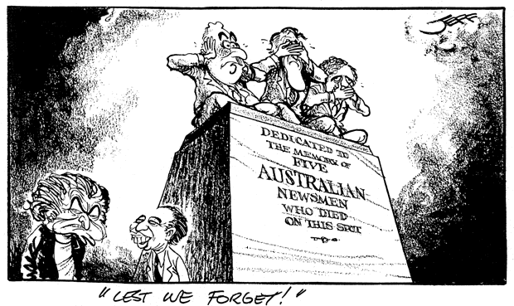

Source 4
(Extract from briefing notes by Gareth Evans (former Foreign Minister) for an article published in The Australian, 27 September 1999.)

Successive Australian Governments certainly pursued good relations with Indonesia. That was obviously true of those of Hawke and Keating all the years I was Foreign Minister. But we didn’t pursue ‘Good Relations’ as a policy end in itself. It was rather a means to multiple other ends … like protecting our security. Advancing our prosperity. Solving problems like Cambodia ... Helping the fourth-biggest country in the world … manage its own social, economic and political transformations. And, not least, helping the people of East Timor … Nonetheless, in getting our message across to Indonesian … leaders, it would help enormously if the Prime Minister [John Howard] did not harp on ‘Australian values’ as the key to our commitment, let alone muse about our role as a deputy in the region to the US global police chief.

